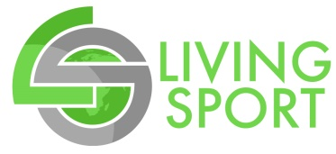 | International Sport Business Program – London 2018

Program Participant Information Form

List your name exactly how it appears on your passport. This information will be sent directly to American Airlines. If your name is listed differently than your passport it will interrupt or cancel your travels.

PLEASE SUBMIT: A copy of your passport will need to be submitted with this form.

Full Name:
 | Last | First | Middle

Confirm the address that your program welcome package will be sent to:

Address:
 | Street Address | Apartment/Unit #

 | City | State | ZIP Code

Cell Phone #: |  | Date of Birth: |  | Gender:

OPTIONAL: Flight miles can be earned through Delta’s SkyMiles Program. Enter your number below or if you do not have a number and you would like to sign-up visit: www.delta.com/content/www/en_US/skymiles.html

SkyMiles #:

Program T-shirt Size: Please choose the t-shirt size you would like us to order for you.
The female shirt will be more form fitted than the male shirt. If you are a female but would rather a men’s sized shirt, please choose what you prefer. Check the box of your preferred style and size.

Shirt Size: Men’s Small Women’s Small
Men’s Medium Women’s Medium
Men’s Large Women’s Large
Men’s X-Large Women’s X-Large
Men’s 2 XL

Will you need special assistance (including use wheelchair) on the aircraft? |  | YES | NO
If yes, explain:

Emergency Contact Information
1. Name: |  | Relationship:
Cell #: |  | Other Phone:
2. Name: |  | Relationship:
Cell #: |  | Other Phone:

