RE: International Sport Business Program

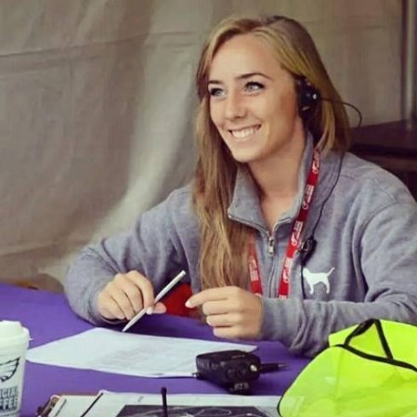
Dear (INSERT SPECIFIC NAME),

I want to share amazing news with you. I have been selected to participate in Living Sport’s International Sport Business Program in Hamburg, Germany this July. My application was one of hundreds submitted, and I am so excited that I was selected to participate. This will be an incredible opportunity for me!
CHANGE TO YOUR PHOTO

During this ten-day trip, myself and other selected participants will receive the opportunity to work on the staff of an international sporting event!

We will also have the opportunity to study sport through local professional teams and venues such as Volksparkstadion – home to football club Hamburger SV, and Millerntor-Stadion - home to football club FC St. Pauli. We will tour the city’s most well-known attractions including St. Michael's Church, Elbphilharmonie and Port of Hamburg, learning all about the history and culture of the city. In addition, I will be attending skills workshop sessions throughout the program which are led by sport industry professionals. These sessions will help advance my business skills and grow my network to further my career for years to come.

This is a great opportunity to grow both personally and professionally, but I still have much work to be done. To take advantage of this offer, I must raise (AMOUNT YOU WANT TO RAISE) to cover program expenses. I ask you to consider becoming a sponsor of mine. Any amount will get me closer to my goal. I appreciate in advance the support you can provide to me, and will keep you up-to-date on my progress.

Sincerely,
BECOME A SPONSOR:
TO DONATE BY CHECK, send to:
Name
Address
City, State, Zip

DEADLINE DATE:

(YOUR SIGNATURE HERE)

TYPE YOUR NAME
TYPE YOUR E-MAIL
TYPE YOUR PHONE NUMBER

Living Sport Program Overview:
www.livingsport.com

